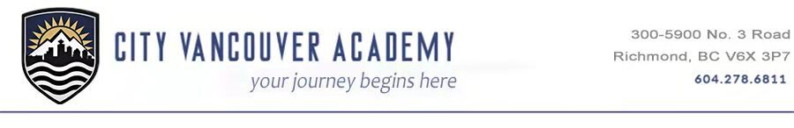
Date:
To:
Attn:
The following student(s) has/have registered at

Name of Student(s) : | Date of Birth : | Grade: | PEN

Please withdraw them from MyEducation BC if you are a MyEducation BC school.
Please forward:
- his/her student file,
- permanent record card,
- any other pertinent information regarding the student(s).
- Special Education File
If the records are not available, please note on this request and return by fax. Thank you. Kindly inform us if this student has a Special Education category.
Thank you,

